**[Unveiling-Market-Insights-Analysing-Spending-Behaviour-and-Identifying-Opportunities-for-Growth](https://github.com/badrinath2004/Unveiling-Market-Insights-Analysing-Spending-Behaviour-and-Identifying-Opportunities-for-Growth)**

Introduction:

Unveiling Market Insights is like peeling back layers to reveal the intricacies of consumer behavior, preferences, and trends. This process empowers businesses to make informed decisions, anticipate market shifts, and discover untapped opportunities for growth.

Purpose:

The purpose of unveiling market insights is to equip businesses with a comprehensive understanding of consumer behaviors, enabling them to make strategic decisions, stay ahead of market trends, and identify avenues for sustainable growth. It's about gaining a competitive edge through knowledge and adaptability.

Empathy Map:

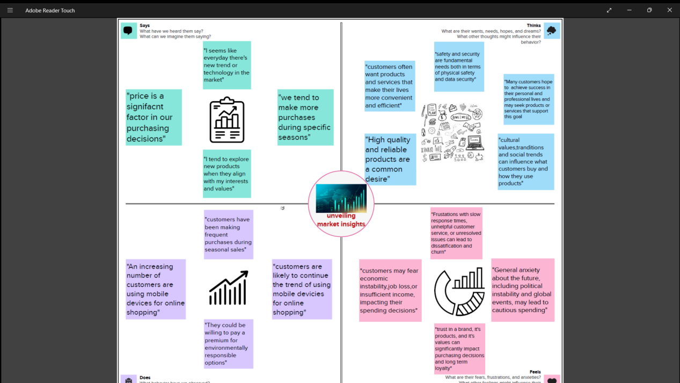

Brainstorming Map:

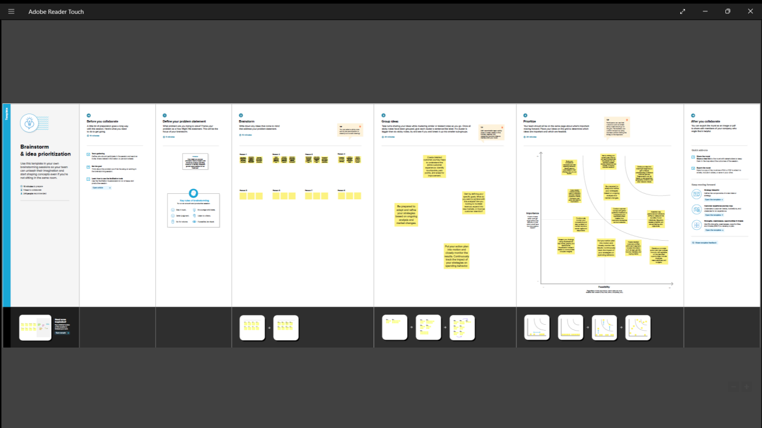

Result:

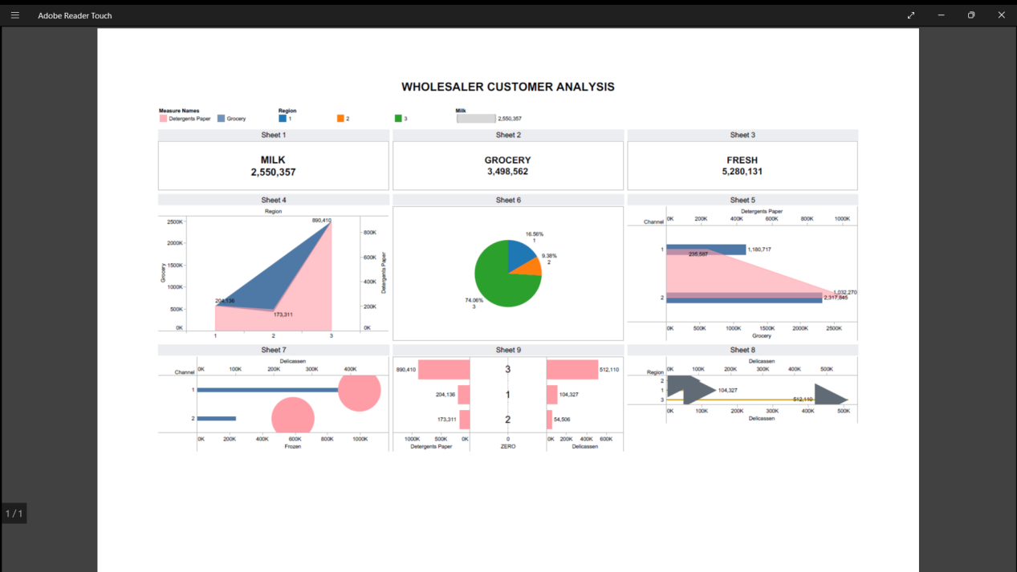

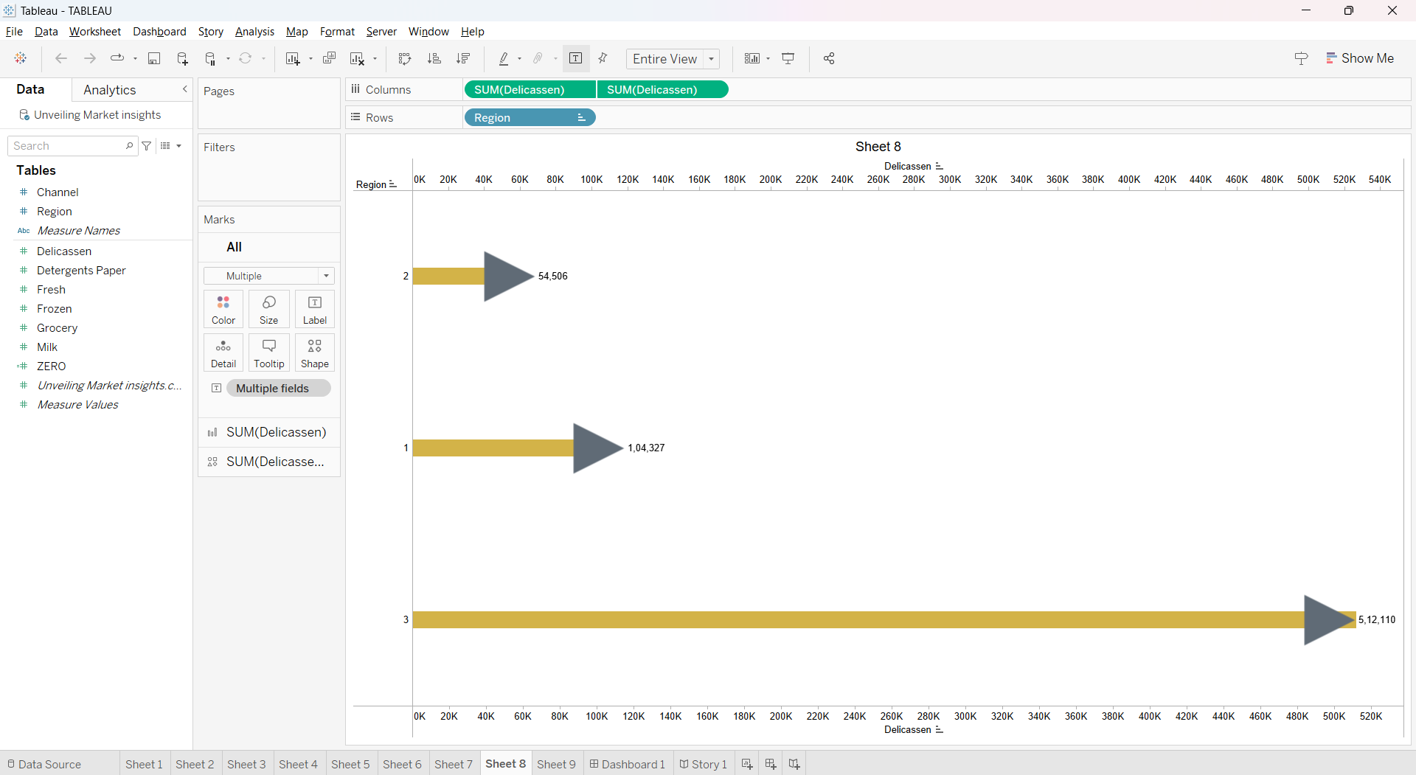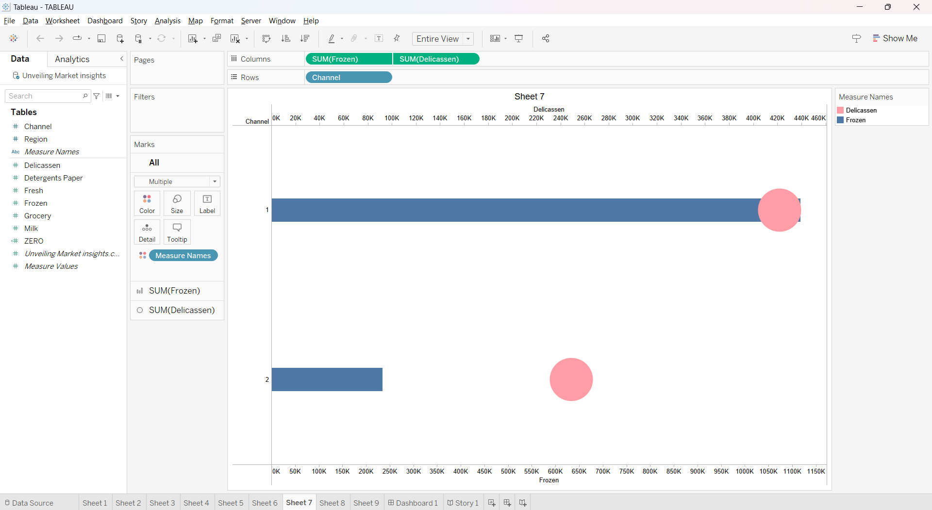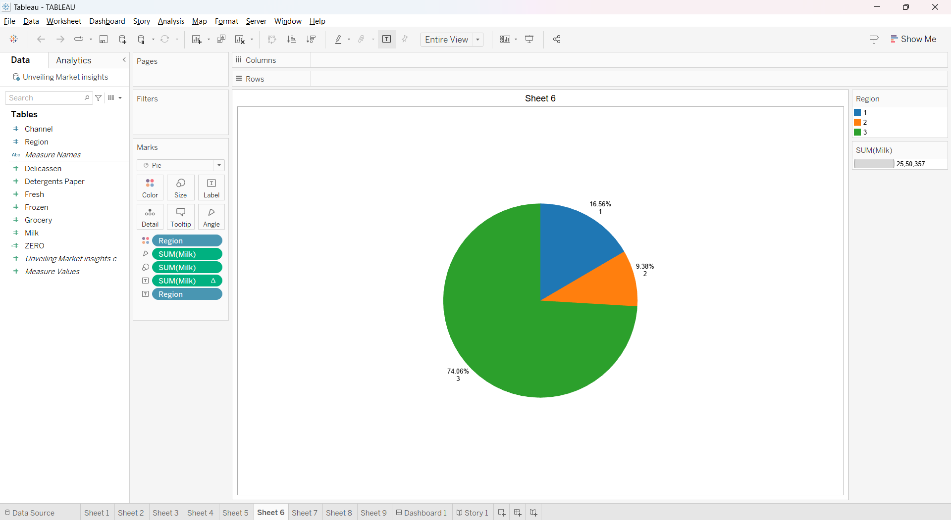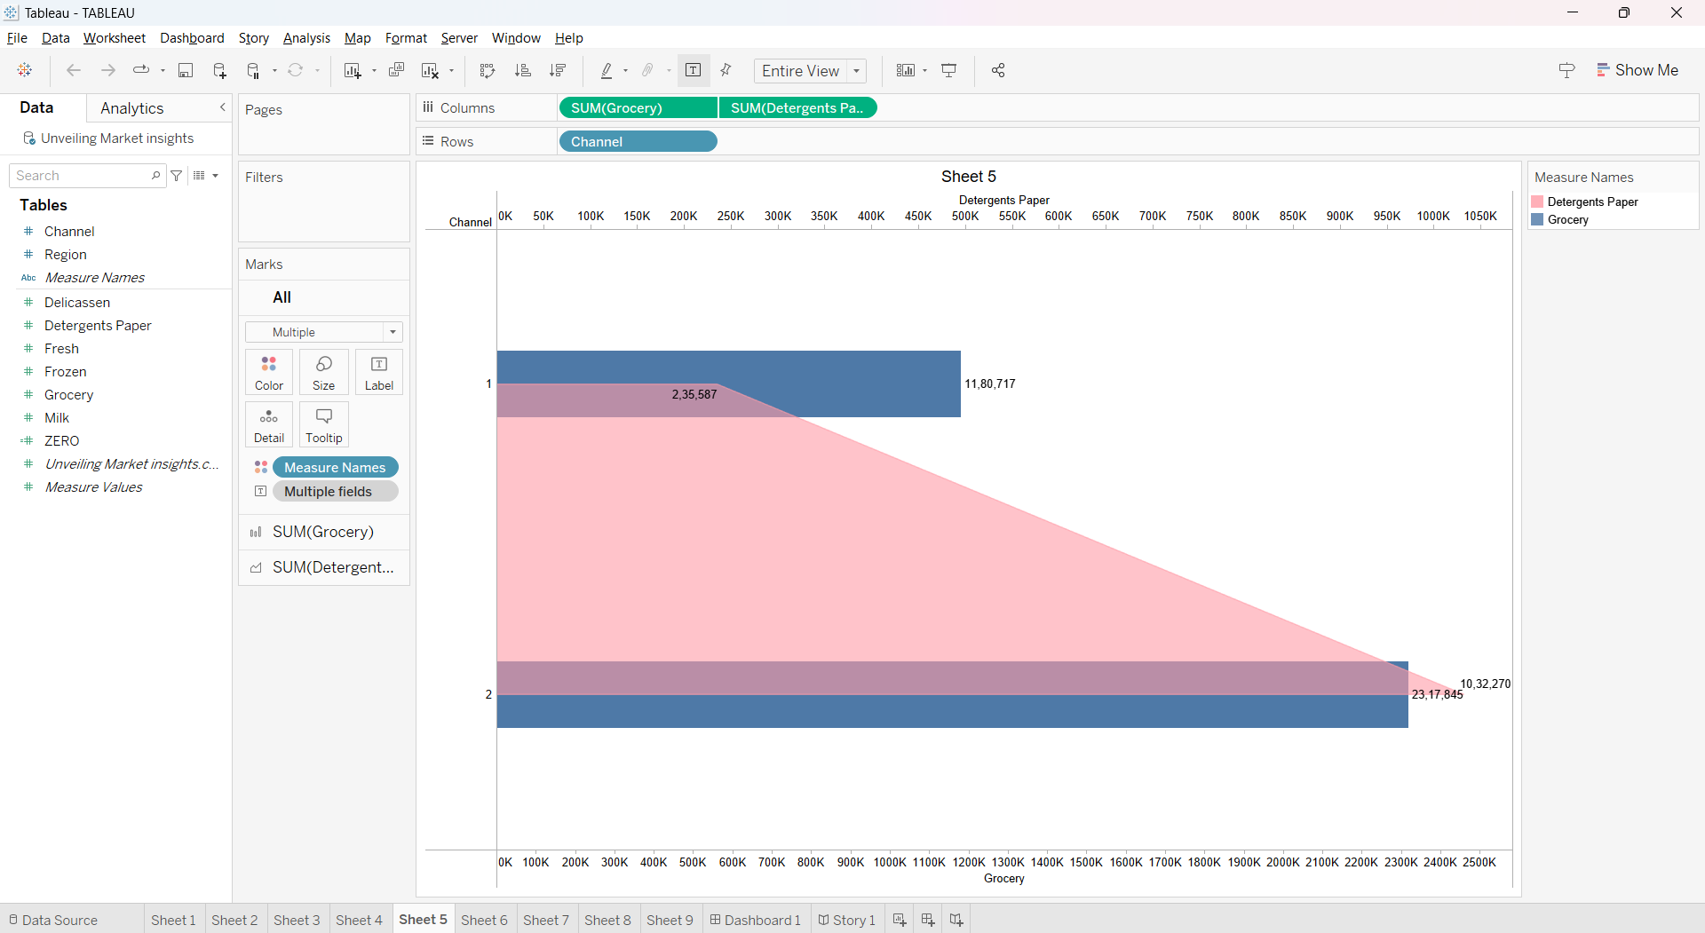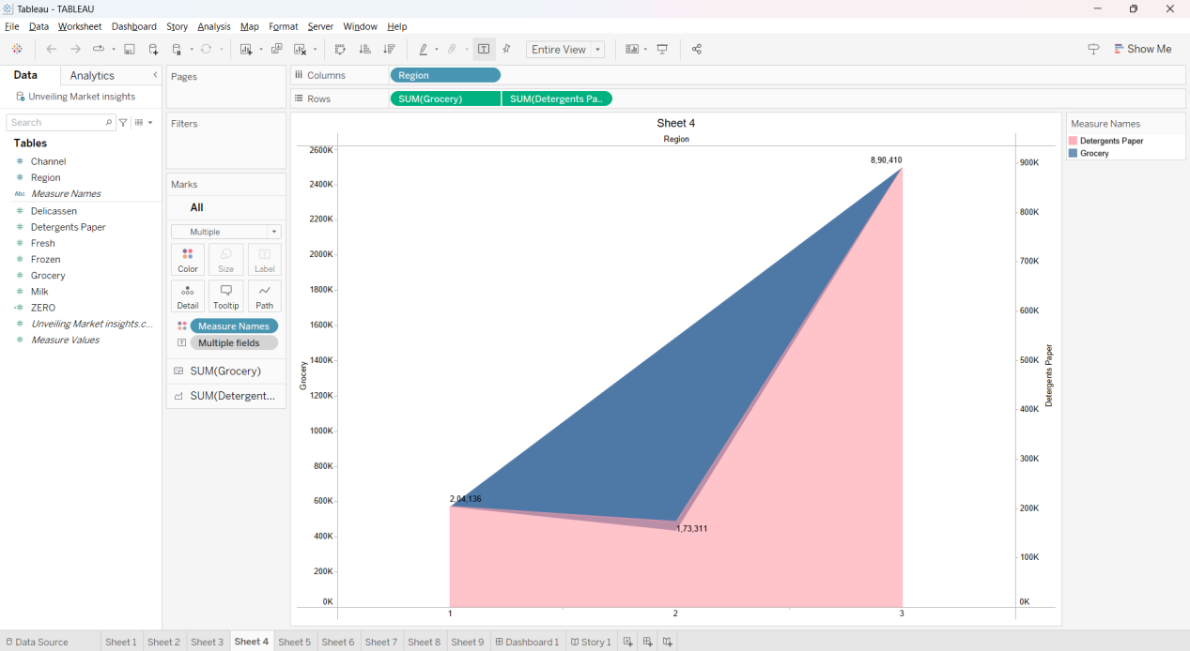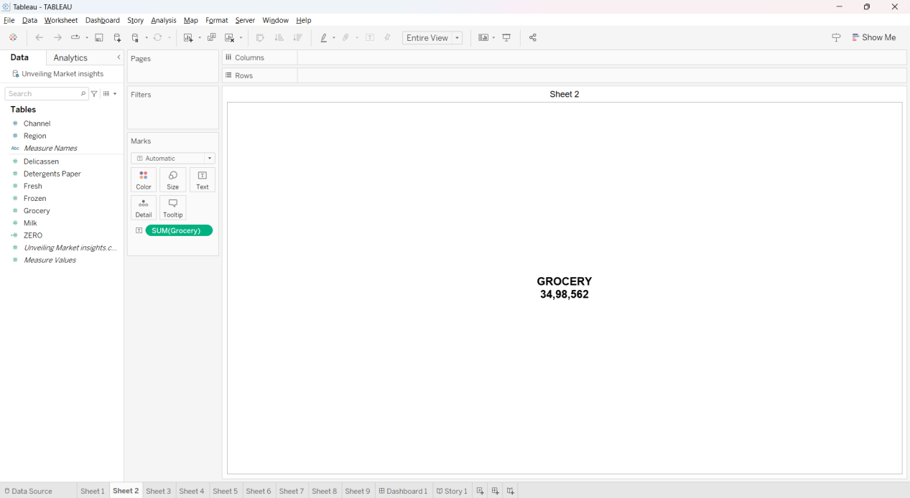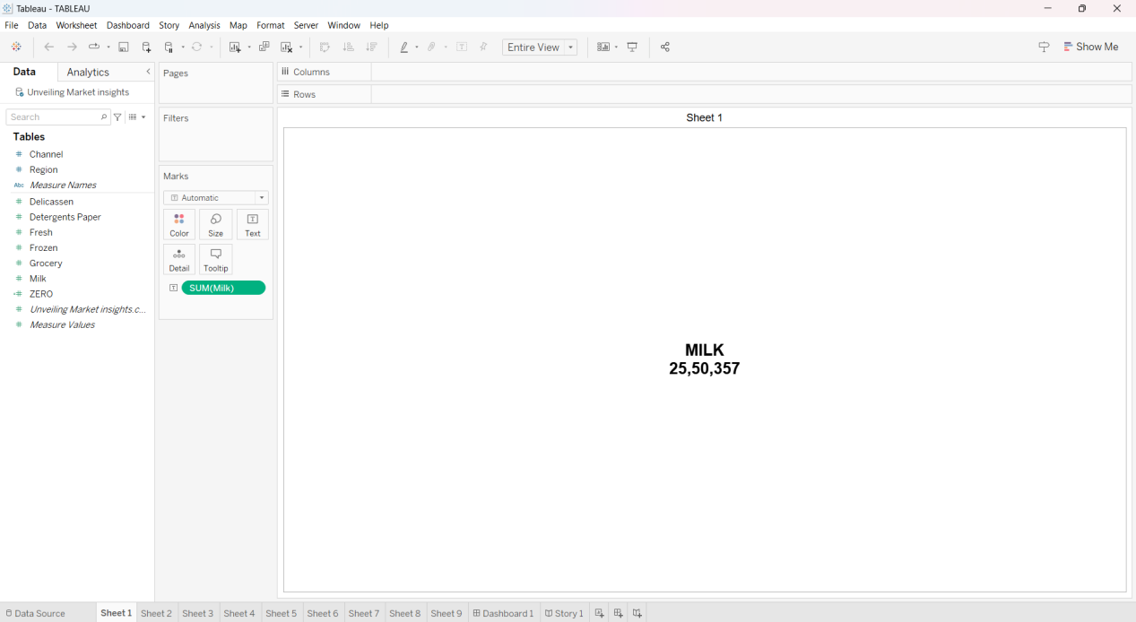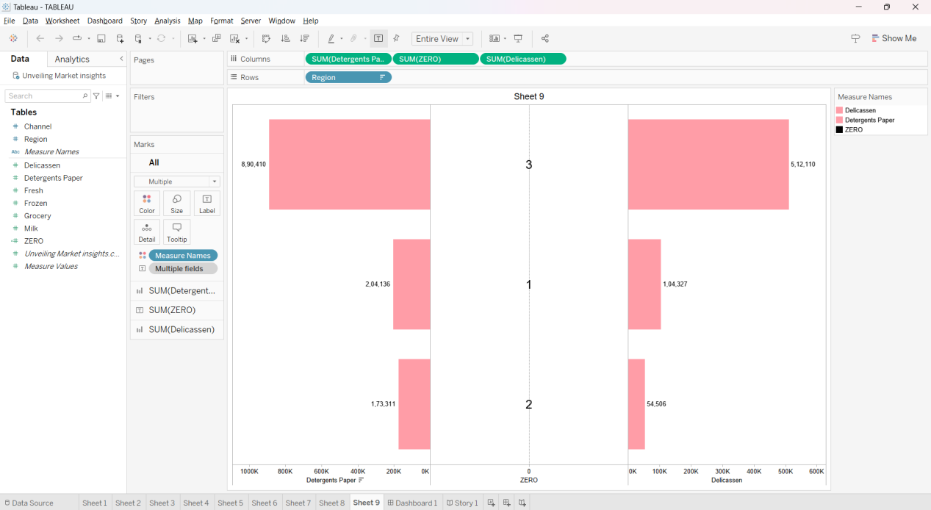

**Advantages**:

Informed Decision-Making: Helps businesses make strategic choices based on a deep understanding of market dynamics.

Targeted Marketing: Enables precise targeting of audiences, optimizing marketing efforts for better engagement.

Competitive Edge: Stay ahead by anticipating trends and responding swiftly to changes in consumer behavior.

Opportunity Identification: Spot untapped markets and niches, unlocking avenues for business growth.

**Disadvantages:**

Costs: Gathering and analyzing data can be expensive, especially for comprehensive and real-time insights.

Complexity: Interpreting vast amounts of data requires expertise, and navigating complexity may pose challenges.

Data Accuracy: Inaccurate or outdated data can lead to flawed insights, impacting decision-making negatively.

Privacy Concerns: Gathering detailed consumer information may raise ethical and privacy issues, affecting reputation.

Overreliance: Depending solely on data may overlook human intuition and qualitative aspects critical for success.

**Application:**

Strategic Planning: Guides the development of long-term business strategies based on a thorough understanding of market dynamics.

Marketing Campaigns: Optimizes marketing efforts by tailoring campaigns to resonate with target audiences and current trends.

Product Development: Informs the creation of products or services that align with consumer needs and preferences.

Risk Management: Helps businesses anticipate and navigate potential risks by staying aware of market shifts.

**Conclusion:**

Unveiling market insights is the compass guiding businesses through the dynamic landscape of consumer behavior. Its strategic application empowers companies to make informed decisions, foster innovation, and stay resilient in a competitive market. By leveraging these insights, businesses can not only adapt to change but also proactively shape their future, ensuring sustained growth and relevance in the ever-evolving marketplace.

**Future Scope:**

Advanced Analytics: Continuous improvement in analytical tools, leveraging AI and machine learning for deeper and more accurate insights.

Real-time Monitoring: Increased focus on real-time data, allowing businesses to respond swiftly to emerging trends and consumer shifts.

Predictive Modeling: Enhanced predictive capabilities to foresee market changes and proactively position businesses for success.

Personalization: Greater emphasis on hyper-personalization, tailoring products and services with unprecedented precision.